**Teacher Information Packet**

Thank you for registering for the USF Engineering Expo! Please print this file and bring it with you to the registration tent. This document contains important information regarding transportation, lunch options, some show times, and more. **Please read the entire document carefully!** The most updated information will be on our website.

Thank you,

Directors of Visitor Relations

**Transportation**

Arrival:

BUS DROP-OFF:

* Please conduct a headcount before arrival to drop-off zone.
* It is preferred that you enter campus at **either** of the following intersections:

1. 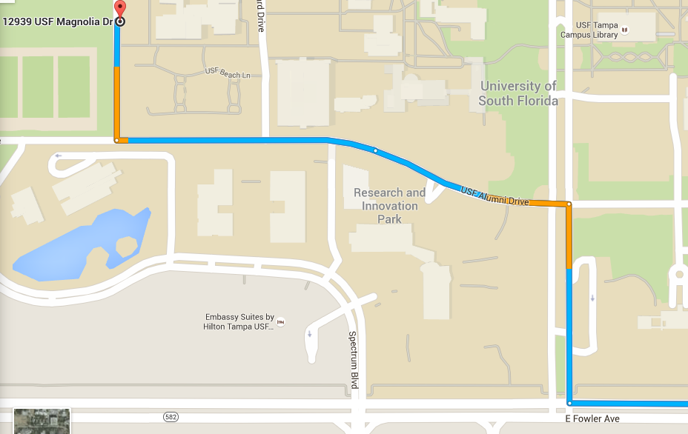Fowler Ave & Leeroy Collins Blvd (map below) From Fowler, turn RIGHT on Leeroy Collins, LEFT on USF Alumni, and RIGHT on USF Magnolia Dr.

**OR** you may enter campus at

2.  Bruce B. Downs Blvd & USF Pine. (Map below)

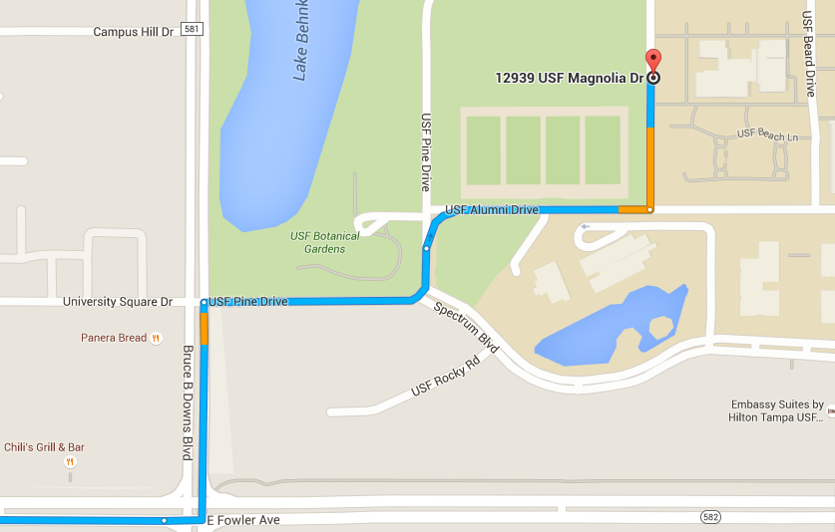When on Bruce B. Downs turn ONTO USF Pine Drive and follow the road to the left. Turn RIGHT on USF Alumni Drive, then turn LEFT onto USF Magnolia.

Upon arrival:

* + DO NOT turn onto Beard Drive, follow signs onto USF Magnolia Dr.
  + University Police will direct buses to an unloading zone.
  + An EXPO volunteer will greet the bus to register your school. **While** the bus is unloading, the chaperone will be asked a few questions:
* School Name
* Number of buses from your school
* Total number of passengers on the bus.
* Your bus driver will be given a numbered sign, please post on bus right side window because it will expedite pick-up process. Same number will be given to head chaperone, and is needed for pick up.
* After the bus is quickly unloaded, notice that dining representatives will have a tent at the unload zone for purchasing meal tickets. Please try to make the least amount of transactions per bus. For example, the chaperone can pool the lunch money and purchase all the meal tickets in one transaction and distribute the tickets to their students before lunch. This will reduce wait times for all students and chaperones.
* Expo volunteers will then direct your school toward the event site

Departure:

All Expo Exhibits will be closing at **4pm.**

BUS PICK-UP:

There is a limited amount of space and time where buses can wait. Therefore, it is imperative to organize your students ahead of time and load your buses as quickly as possible. Please perform headcounts before/while getting on the bus.

* Please arrange for the students to reach loading zone **before** their assigned bus arrives. This way buses are not parked waiting for their students to arrive and traffic flows with less congestion.
* Follow volunteer directions and signs back to the same load/unload point where you can sign out at a designated check out table and turn in your number card.
* An EXPO volunteer will then direct you to the pick-up staging area, and you will be notified when your bus arrives. Upon bus arrival:
* Quickly board the bus and perform final headcount WHILE boarding.
* Please return numbered cards.

*Plan to spend the least amount of time at the loading and unloading areas.

***The goal is to minimize the amount of time each bus is parked in the loading/unloading area.***

Parking for Parents:

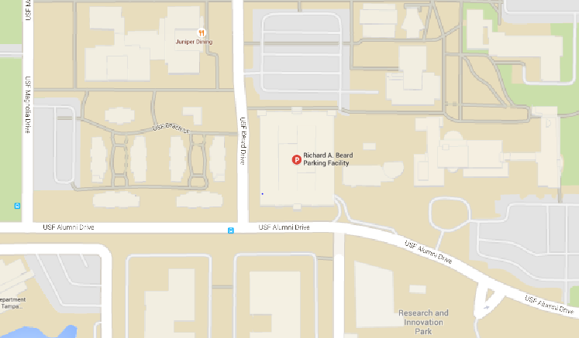Free parking is available for parents and other guest in the Beard Parking garage for free on levels 3 to 8. There will be signs directing parents and other guest where to park and exit to the event. Address: Richard A. Beard Parking Facility, Tampa, FL 33620

**Lunch**

Every school may pack their own lunches or purchase lunch at the Expo. There will be seating for everyone. For those who plan to purchase, details are below:

*REMINDER: Expo is not responsible for watching over lunches, so **NO COOLERS** are allowed this year. Students may carry their own packed lunches, but cannot leave lunches on the buses. Buses will not be parked on campus.



Lunch will be served by USF catering services.

**The 2017 Expo Menu will include an entrée, chips, and a drink for $7.**

**Entrées:**

* Papa John’s Pizza Cheese/Pepperoni
* Beef O’ Brady’s Boneless Chicken wings
* *Vegetarian options (must be requested by catering email)

**Contact for Prepaying Options Purchases and Entrée Accommodations: -** Savannah Newson: [usfcatering1@gmail.com](mailto:usfcatering1@gmail.com), 813-974-0798

* There will be a designated area for which lunch will be served, and you will be able to purchase and receive lunch there on the day of the event.

**Pre-ordering is now available. Kindly complete the food voucher order form below to pre- order lunches. Feel free to contact our catering services directly with any comments, questions, and concerns.

**Exhibits and Show Information**

We are working on updating these forms and will inform you once they are all complete. You can also keep your eye out for the exhibit list as well <http://expo.eng.usf.edu/exhibitor.html>

Scavenger Hunt:

We are looking forward to this annual tradition! The 2017 Engineering Expo will be having a scavenger hunt for all of the schools attending. The scavenger hunt will be based off various exhibits and shows. This is another great way to engage students in science, engineering, and math! Please note that this scavenger hunt is OPTIONAL. We will be sending out the scavenger hunt sheets closer to the event. If you wish for your school to participate, simply print out as many sheets as you need. Copies available day of will be limited. Please inform the person signing you in that your school is participating when you arrive at Expo.

Maps and Other Documents

The 2017 EXPO program/map as well as many other documents you may want to look at will be available for download on the EXPO website <http://expo.eng.usf.edu/>maps.html

Once they are updated fully, we will inform you. Feel free to print and bring copies for yourself to the event, there will be limited day of Expo. Copies will be available on a first come, first serve basis.

Mobile App

This year we will be integrating an app to ensure easier access to information on the go. Details are as follows:

* Name: USF Engineering Expo
* Platforms/ App Stores: Google Play & Apple Store
* Available on the app: Maps, Exhibits, Important Documents, etc.

**The app is not yet available but will be available shortly. Feel free to check back regularly, or download shortly before Expo.

**Please Keep in Mind:**

* All instructors/teachers are responsible for controlling their students.
* Please help us maintain a clean and safe USF campus. Assure students do not mark, kick, or tamper with equipment in or around the facilities.

These include:

* + Emergency eyewash and showers.
  + Statues and landmarks.
  + Mulch and pebble gardens.
  + Foliage.
  + Walls, doors, and windows.
  + Chains, bollards, barriers, and signs.
  + Student exhibits, unless instructed to participate.
  + Restrooms.
* Only use campus walkways to move around.
* Be aware of instructions from Engineering Expo volunteers who will assist in crowd control.
* Become familiar with EMT location on map and actual site.
* In case of emergencies, notify the nearest instructor/teacher, Engineering Expo volunteer, police officer, or EMS officer.
* In case of rain, do not get separated from your groups.

***Remember:*** We want every student and participant to thoroughly enjoy the time spent at our event. We desire everyone to grow, learn, be challenged and be inspired from the activities and experiments at our event!

We are look forward to having your school participate in Expo with us this year! It will be an exciting and new experience!

Please remember, if you have additional questions please check the FAQs on our website or email [usfexpo.schools@gmail.com](mailto:usfexpo.schools@gmail.com).

Thank you,

Emily Pretorius & Megan Hostetter

Director of Schools Communication

2017 Engineering Expo